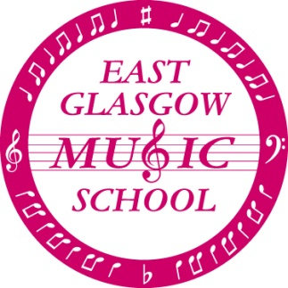

CHRISTMAS INFORMAL CONCERT

We will be holding our annual Christmas Informal Concert on

Saturday 8th December 2018
10.00am – 11.15am (approx.)

This is an opportunity for all children to bring along their parents, family and friends to see what we’ve been working on this term. The choirs, orchestra and recorder group will all be performing the pieces they've been practicing so come along and join in the singing and get into the festive spirit.....

Donations for raffle prizes would be very welcome and should be brought to Music School on Saturday 1st December. Please note that any donations of alcohol must be brought by an adult.

Please can all children arrive at the school at 9.30am. Choirs will meet in the usual rehearsal room. Dress is festive and Santa hats and reindeer antlers are welcome (but not required!)

Following our Informal Concert, Music School will be on holiday until Saturday 12th January 2019 when classes will resume as normal. Dates for next term are as follows:

12th January 2019 - 2nd February 2019 - Normal Timetable

9th February 2019 - Half-term holiday

16th February 2019 - 23rd March 2019 - Normal Timetable

30th March 2019 - 13th April 2019 - Spring holiday

It is likely that The Glasgow Music Festival will take place on Sunday 10th March 2019 and further details will follow next term. Copies of all letters and diary dates can also be found on our website www.eastglasgowmusicschool.org.uk and if you're on Facebook please follow us @EGMS2017 for the latest news.

We look forward to seeing you all on December 8th.

THE MUSIC SCHOOL TUTORS

